**# User Manual of SF-MobiGlider Sit to Stand Moonwalker**

**## Introduction**

The Tzora SF-MobiGlider is a rehabilitation equipment designed to assist individuals with physical discomfort or disabilities in standing and sitting anywhere they go. It provides easy access to high items and combines "Moon walking" training to effectively exercise upper limb muscles and improve endurance.

Due to continuous quality improvements and innovative frame development, some details in this manual may differ slightly from the actual device. The company reserves the right to make modifications, so please refer to the actual device for the most accurate information.

**## Table of Contents**

1. Safety Instructions

2. Parts and Diagrams

3. Operation Instructions

4. Maintenance and Care

5. Troubleshooting

6. Warranty and Contact Information

**## 1. Safety Instructions**

1. Please read this instruction manual carefully before use.
2. Users need to have a sound grasp of upper limb function.
3. Users must be accompanied by escorts when first using the device.
4. When the SF-MobiGlider is stationary, insert the parking pin to prevent it from

sliding.

1. The SF-MobiGlider should only be used on flat surfaces and is strictly prohibited for uphill or downhill use.

**## 2. Parts and Diagrams**

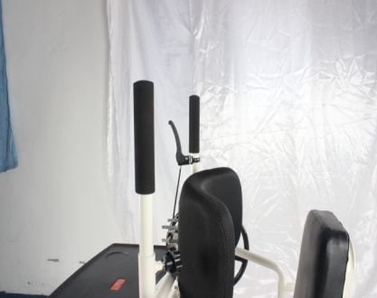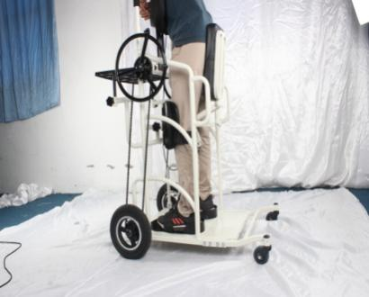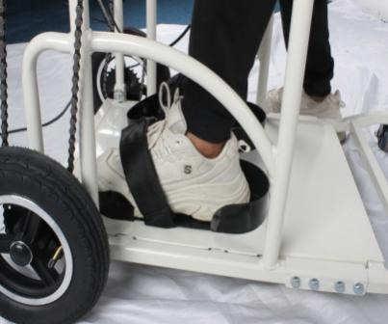

graph 1 graph 2 graph 3

### Graph 1: Overview of SF-MobiGlider

* Key components and their locations

### Graph 2: Brake Handle and Seat Mechanism

* Details on the brake handle and seat adjustment

### Graph 3: Turntable Mechanism

* Information on the turntable for directional control

### Graph 4: Foot Placement

* Correct foot positioning on the device

### Graph 5: Knee Pads and Breast Care Adjustment

* Proper fastening of knee pads and adjustment of breast care

### Graph 6: Parking Brake

* Instructions on the parking brake and pin insertion

**## 3. Operation Instructions:**

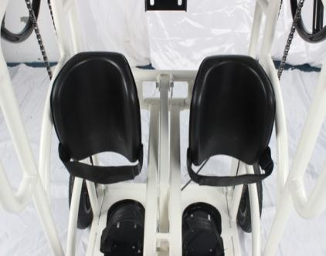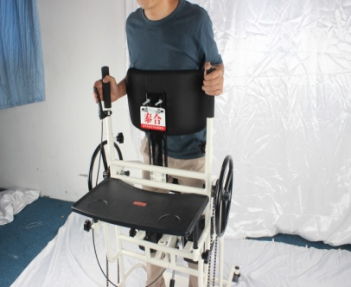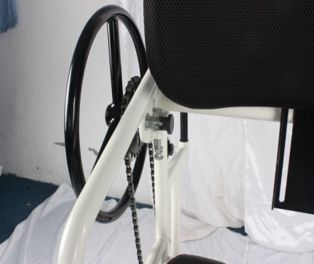

graph 4 graph 5 graph 6

**### Initial Setup**

1. **Brake Handle and Seat Adjustment**: For the first time, hold the brake handle and press the seat back until the seat is flat.

2. **Seat Movement**: Pinch the brake handle to move the seat up and down. Release the brake handle to lock the seat in place. (See Graph 1)

3. **Turntable Adjustment**: Rotate the turntable on both sides to adjust the direction of the SF-MobiGlider. (See Graph 2)

4. **Foot Placement**: Ensure your feet are correctly positioned on the SF-MobiGlider. (See Graph 3)

5. **Knee Pads**: Fasten the knee pads securely. (See Graph 4)

6. **Breast Care Adjustment**: Adjust the breast care position to match your height. (See Graph 5)

7. **Parking Brake**: Insert the pin into the parking brake to secure the SF-MobiGlider when not in use. (See Graph 6)

## 4. Maintenance and Care

* Regularly check all moving parts and fasteners for signs of wear or damage.

* Clean the device with a damp cloth and mild detergent; avoid using harsh chemicals.

* Lubricate the moving parts periodically to ensure smooth operation.

* Store the SF-MobiGlider in a dry place when not in use to prevent rust and corrosion.

## 5. Troubleshooting

### Common Issues and Solutions

**Issue**: The seat does not move up or down.

**Solution**: Ensure the brake handle is pinched properly. Check for obstructions in the seat mechanism.

**Issue**: The device is not stable on flat surfaces.

**Solution**: Verify that the parking pin is inserted correctly and that all wheels are on a flat surface.

**Issue**: Difficulty in adjusting the turntable.

**Solution**: Lubricate the turntable mechanism and ensure it is not obstructed.

## 6. Warranty and Contact Information

The SF-MobiGlider comes with a one-year warranty covering manufacturing defects. For service, repairs, or any other assistance, please contact our customer support team.

**\*\*Customer Support\*\***

* Phone: +972-3-5502020

* Email: sales@tzora.com

* Website: [www.tzora.com](http://www.tzora.com)

---

Thank you for choosing the **Tzora SF-MobiGlider**.

We are committed to providing you with the best rehabilitation equipment to enhance your mobility and independence.