

**SpeedFloAT SF-65S**

**Power wheelchair wheelchair User manual**

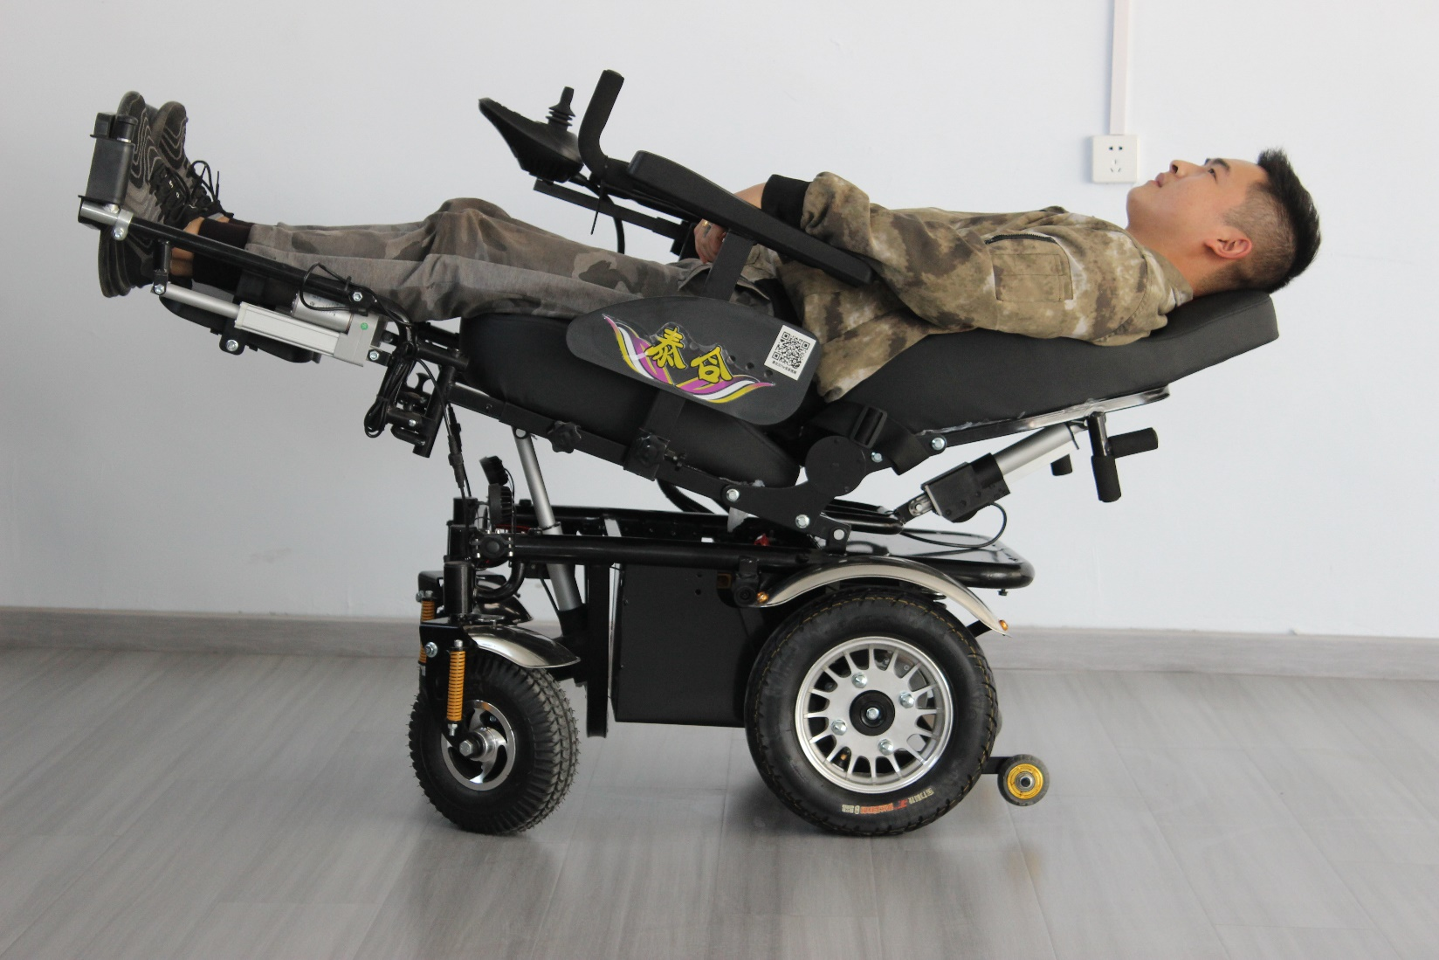

TABLE OF CONTENTS

1. Practice before operating 3
2. User’s safety 3
3. Driving outdoor. 4
4. Driving over the hills and on uneven terrain 4
5. Technical parameters. 5
6. Battery and charging 10

7 Comfort adjustment 11

1. Maintenance and cleaning 15
2. Specification 17

Please, read the instruction carefully before the first use of the wheelchair. If any part of the text is not clear or if you need any further information, please, contact your dealer.

The PCBL wheelchair is designed according to the latest trends and technology. Its construction

enables optimal adaptation to user’s needs. Solid and durable construction, innovative solutions and reliable safety systems guarantee maximum comfort of use.

In order to ensure smooth wheelchair operation and safety the wheelchair should be regularly checked at a service point. In case of any doubts or needs, please, do not hesitate to contact your local dealer or service point.

Please, make sure that you filled in the guarantee form and that you returned it to your dealer. It will help to ensure the best service.

## Not following the instruction may result in vehicle damage or serious injury.

# PRACTICE BEFORE OPERATING

* + Before driving the vehicle on everyday basis, you should find an open area such as a park to practice maneuvers .
  + We recommend that when you practice driving you should be accompanied by an assistant.
  + Always make sure that the vehicle is set off before getting in or getting out of the vehicle. Always check that the speed setting is chosen according to your experience and skills.
  + While practicing, keep the speed at the slowest position.

In order to drive safely, make sure that you are familiar with vehicle characteristics and ways of driving.

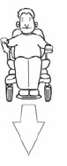First, practice moving forward.

Make sure that the speed is set on the slowest position.

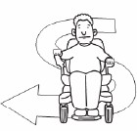Then, practice “S” turns.

Finally, practice driving backwards.

Please, mark that while driving backwards the vehicle always moves slower regardless of the speed setting.

# USER’S SAFETY

* + Do not carry passengers
  + Do not drive after drinking alcohol
  + Consult your physician to check if your medications impair your driving abilities
  + Do not use any personal communication devices such as CB radios, cellular phones
  + Do not tow a trailer
  + Do not drive across a slope

# DRIVING OUTDOOR

* + The wheelchair is not designed to move in the street traffic
  + Do not use the wheelchair during rain or snow, when the temperature is higher than 30°C or lower than 0°C
  + Do not use the wheelchair on soft, uneven, unprotected surfaces such as grass, gravel, sand or decks, beside a river, lake
  + Do not use the wheelchairs for off-road driving
  + If possible, do not use the wheelchair outdoor at night
  + Make sure that there are no obstacles behind you when you drive backwards. We also recommend setting the speed at the slowest position
  + Do not stop suddenly, always try to make turns gently
  + Always keep your arms on the armrests and feet on the footrest while driving
  + Do not try to climb curbs higher than 7cm
  + Do not try to drive over a hole/gap wider than 10 cm

# DRIVING OVER THE HILLS AND 0N UNEVEN TERRAIN

Driving on the hills and other uneven terrains is more dangerous than driving on flat surfaces. Following the below rules is essential to avoid accidents and serious injuries.

* + Do not try to climb a hill which grade exceeds 10°
  + Do not move backwards while going up/down the hill
  + Do not use the wheelchair on soft, uneven, unprotected surfaces such as grass, gravel or sand
  + When you drive down the slope, choose the slowest speed
  + Do not get in or off the wheelchair if it stays on a slope (in order to get in/off the wheelchair you need to place it on flat surface)
  + Always climb or descend the hills perpendicular to the slope.

## Electronic control panel

Electronic control panel allows to control power wheelchair, battery power status and general condition of the whole electronic system.

Electronic control panel is usually placed on the armrest and joint to the battery and motor. The panel can be attached to the left /right armrest or behind the wheelchair (when it is used by a caregiver).

## Controller

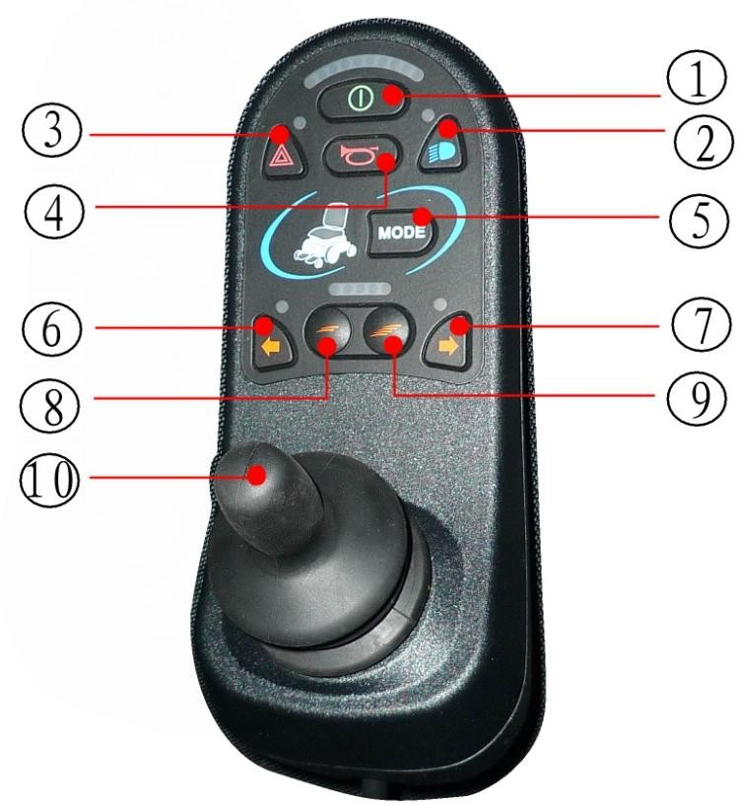

Switch on button

Warning lights button

Driving lights button

Horn button

Mode button

Left turn signal button

Right turn signal button

Deceleration button

Acceleration button

Joystick

**Joystick**

The joystick allows to control direction and speed of movement. Push the joystick forward to release the electromagnetic brake and set the wheelchair in motion. The more you push the joystick forward, the faster the wheelchair will move. If you release the joystick, the wheelchair will slow down and stop.

**Mode**

1. 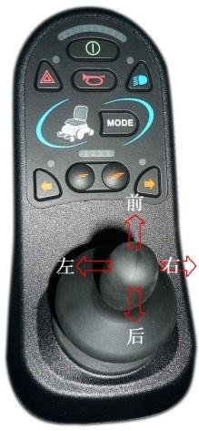adjusting backrest, seat and footrests

The joystick allows you to adjust backrest, seat and footrest position. Move the joystick to left or right side to choose the wheelchair’s part you want to adjust. When you push the joystick forward, the chosen part will be moved upwards. When you move the joystick backwards, it will be lowered.

1. driving mode

The joystick allows you to control and maneuver the wheelchair. Push the joystick forward to move straight on. Move the joystick backwards to drive in

reverse. In order to turn left/right, move the joystick to left/right side. If you want to stop, release the joystick.

## Battery status bar

You can find the battery status bar at the top of controller. Using the color light indicator, the battery status bar provides information on supply, approximate power of the batteries, electric systems of the wheelchair using a color code.

Constant red, yellow and green light indicate that batteries are fully charged, electric systems and electronic system of control panel are efficient.

Constant red and yellow light indicates that you should charge batteries, the electric systems and electronic system of control panel are efficient.

Only constant red light or slowly blinking red light – you should charge the batteries as soon as possible, the electric systems and electronic system of control panel are efficient.

If the lights blink, the electronic system or electric system does not work properly. If the warning lights blink 6 times the left motor is damaged. If the warning lights blink 5 times, the right motor does not work properly.

If the warning lights blink continuously, the joystick was not is neutral position when the power wheelchair was switched off. Turn off the power, release the joystick and again turn on the power.



**WARNING!** If you followed the user’s manual instructions but the warning lights are still blinking, please, contact your dealer.

## Speed adjustment buttons

There are two speed adjustment buttons – if you want to slow down, press deceleration button. The actual speed is shown on the indicator placed below the battery status bar. The faster you move, the more lights are on.

## Horn button

Press the button to activate the horn.

## Charger socket

The socket is used for battery charging – plug to the power outlet (max 12A).

## Driving lights button

When you switch on the driving lights, the corresponding light icon will activate.

## Left turn button

When you press the button, the corresponding light icon will activate. In order to switch off the winker, press the button again.

## Right turn button

When you press the button, the corresponding light icon will activate. In order to switch off the winker, press the button again.

**Warning light button** Activates the warning lights. **Motor clutch**

Clutch lever



1. If you want to push the power wheelchair, pull the clutch lever to open side.
2. Automatic drive: pull the cluth lever to close side. n



**WARNING!** Please, remember that when the system of electric drive is turn off, the electromagnetic brakes are also disconnected.

Never switch off the electromagnetic drive if there is no person who may push your wheelchair.

Never switch off the electromagnetic drive if the wheelchair is staying on the slope or on any other inclined terrain – the wheelchair may go downhill which may lead to wheelchair damage or injury.

## Charger



Charger plug connection

1. Plug the charger output cable to into the charging socket in the bottom part of the controller.
2. After connecting the charger output cable to the charging socket and to the power outlet, turn on the electronic control panel. The battery status bar will blink back and forth.
3. Wheelchair will not move while charging, even if the joystick is pushed.

## Power switch:

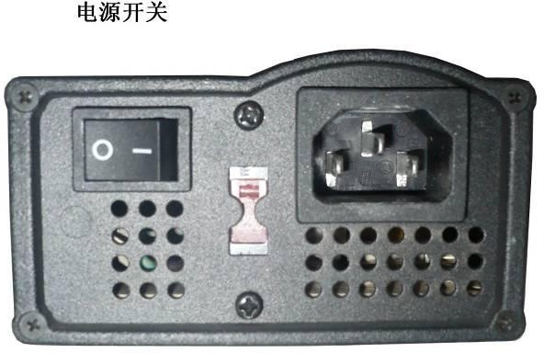

Power switch

“- “ switch on button “O” switch off button

In order to switch on the charger, press the button to switch it into “-“ position.

## Charging indicator lights

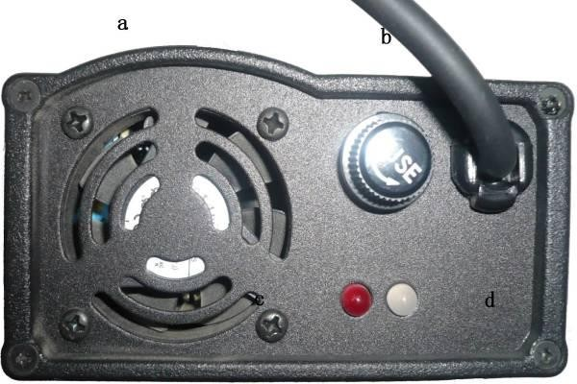

fan

fuse

orange light: charging in progress

yellow light: charging completed, batteries are fully charged

Control indicator light Charging indicator light

# 6. BATTERY & CHARGING

The charger is the key part of the wheelchair. In order to charge the batteries quickly and safely ,use only the original charger supplied with the wheelchair and follow the below rules.

1. Always plug the charger into the charging socket placed at the bottom part of the controller. Then, plug it to the power outlet.
2. Follow the instruction outlined on the charger board.
3. The time of charging depend on battery condition. The best option is to load batteries at night- when batteries are loaded, the charger will stop working automatically.
4. When loading is completed, remove the charger from power outlet and then from the charging socket. Never leave the charger connected to the charger socket if it is not connected with power outlet.

If you need to replace the batteries, please, contact your distributor.





**WARNING!** Never plug the charger into the power outlet of more than 12 V. Always use the original charger supplied with the wheelchair. Not following the above rules may lead to charger overheating and fire. Do not charge the batteries in humid places, conditions. Never stop or suspend charging if the batteries are not completely charged. The charging should last till the time the batteries are fully charged.

# 7. COMFORT ADJUSTMENT

First, choose the adjustment mode on your controller

Push the mode button on the controller and choose the adjustment mode.

Please, look at the wheelchair icon placed on the controller – it will indicate which wheelchair’s part (backrest, seat or footrest) is ready to be adjusted. Move the joystick to left or right side to change

the wheelchair’s part you want to adjust. When your choice is made, the relevant light indicator will light to show you which part will be adjusted. When you push the joystick forward, the chosen part will be moved upwards. When you move the joystick backwards, it will be lowered.

When all the adjustment are made, push the mode button again to choose the driving mode.

wheelchair icon



Mode button



## Armmmrest adjustment

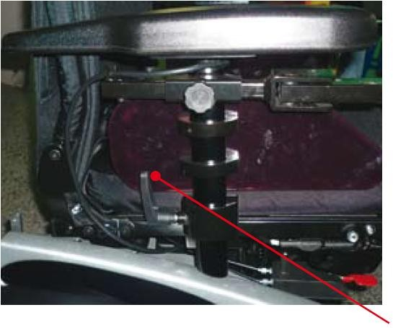In order to adjust the armrest height, loosen the handle, choose the required armrest height and screw in the screw.

handle

## Controller adjustment

Hand adjustable screw

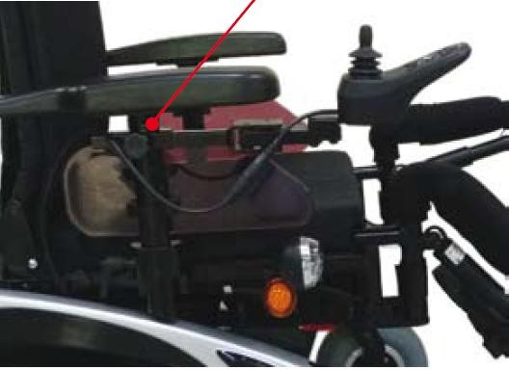

Exemplary positions of the controller:

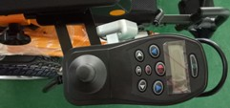A B

It is possible to adjust the controller position to individual needs. Loosen the hand adjustable screw placed under the armrest and choose required controller position as shown in picture A and B. Then screw in the screw. The controller may be placed on the right or left armrest. It can be also placed at the back of the wheelchair and used by the caregiver.

## Battery removal

In order to remove the batteries: Pull the battery tray latch up (as shown in Figure 2)

And pull out the battery tray (as shown in Figure 3).

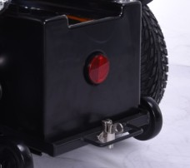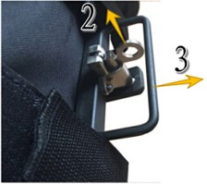

## Battery

The wheelchair is equipped with two 12 V maintenance-free batteries.

In order to obtain maximum efficiency of your battery please, follow the instructions below:

1. Charge each battery before the first use. The batteries will reach 90 % of their capacity.
2. Use the power chair moving slowly not far away from the place where you can charge the batteries again until the batteries discharge completely. Then charge them again for 9-10 hours.
3. After four or five such charging cycles the batteries should top off at 100% charge capacity and last for long time.

The batteries are equipped with overload protector (75AH) which automatically disconnects a load when current exceeds a predetermined value.

When the wheelchair is overloaded, the overload protector will spring up and disconnect a load. If the motor is overloaded, stop the wheelchair and wait till the motor is cooled down. Then, push down the overload protector and reactivate the wheelchair. If it is not possible to reactivate the wheelchair, please, contact the service point.



**WARNING**

Never let the batteries unload completely. If you notice last yellow or first red light indicator on the controller- charge the batteries. Remember that the charging cycle should take about 9-10 hours, till the batteries are fully charged.

Never stop or suspend the charging if batteries are not fully charged. Not following the above rules may lead to battery damage.

If you store the batteries, make sure they are fully charged.

If you do not use your wheelchair on regular basis, you should charge the batteries at least every two weeks. Remember that each charging must be completed and last about 9-10 hours, till the batteries are fully charged.

If you notice any leakage from the battery, please, contact your distributor.

When charging the batteries, always keep the wheelchair and charger away from any heat source.

## Safety belt

Safety belts will protect the user when driving the wheelchair. Always remember to fasten the safety belts before starting the wheelchair.



## Anti-tip wheels

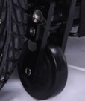The anti-tip wheels protect the wheelchair against falling in case of slight side tilts, they provide better stabilization. It is possible to fold or unfold the wheels as shown in the pictures below:



# 8. MAINTENANCE AND CLEANING

In order to ensure that your wheelchair will give you years of trouble-free operation, the user should regularly inspect and maintain the wheelchair and deliver it to the authorized distributor for annual comprehensive maintenance and inspection. If you find any problems or abnormalities while using the wheelchair, please, contact the nearest authorized service point.

**Annual inspection**

Annual inspection is to check if the wheelchair is in good shape and if all the systems (driving system, electric and electronic systems) work properly. It also helps to prevent possible problems which may arise from existing defects. The inspection should include:

1. Tire inspection
2. Inspection of the battery and the wiring
3. Inspection of the controller control program and checking if it requires re-editing.
4. Inspection of the main frame
5. Inspection of backrest and seat cushions

**Maintenance and cleaning – general rules**

1. Protect the controller and joystick against violent shakes and hitting.
2. Avoid long exposure of the power wheelchair to extreme cold, hot or humidity.
3. Always keep the controller and joystick clean.
4. Keep the wheelchair away from direct contact with water.
5. Always keep the frame and upholstery clean. Use soft, dry cloth to clean the main frame and the upholstery. Do not use any abrasive. While cleaning, do not use any detergents directly on the controller, battery charger or other power connectors.
6. Lightly oil axle pin, wheel axle and bearings every three months.
7. Use only the original batteries supplied with wheelchair. If you want to replace the batteries, contact your distributor.
8. Regularly charge the batteries. Always make sure that the charger is properly connected to the power output. Never disconnect the charger by pulling the cord.
9. Regularly inspect the joystick condition – switch off the power and check if the joystick is not damaged. Try to push the joystick and then release it - it should automatically go back to its neutral, central position. Check the rubber boot around the base of the joystick for damage. Visually inspect the boot. Do not handle or try to repair it. See authorized dealer if there is any problem.
10. Carefully check all the wires – if you notice any damage contact the authorized service point. Make sure that all wiring connections are correct and proper; do not over-tighten the screws.
11. Ensure that all parts of the controller system are securely fastened to your power chair.
12. Your power wheelchair should be stored in a dry place free from temperature extremes. When storing, disconnect the batteries from the power chair, see ”Batteries and charging” in this manual. If

you fail to store the unit under the above conditions, the frame can rust, and the electronics can be damaged.

## Problem checklist

1. Problem: The controller lights blink quickly when the power is switched on.

Action: Switch off the power, put the joystick in its neutral position. Then wait few seconds and reactivate the wheelchair

1. Problem: The controller lights flash slowly while driving.

Action: The slow flashing means that the battery charger level is low and the batteries should be charged as soon as possible.

1. Problem: The controller lights flash continuously and it is not possible to control the wheelchair. Action: The continuous flashing of the lights indicates there may be an electrical problem. Switch off the power and contact your authorized service point.
2. Problem: The red controller light placed on the battery charger does not light during charging. Action: Check that all the wires have been properly connected and plugged into a power outlet. If the red controller still does not light, disconnect the battery charger from the power outlet and

control panel, switch off the wheelchair and contact authorized service point.

1. Problem: The chair is difficult to steer.

Action: First, check if four wheels are properly installed on the power wheelchair. Second, check to see if the clutch lever is engaged correctly.

NOTE: If you detect that the there are problems with the motors, the battery charger, the controller or damage to the power chair frame, it is recommended that you contact the nearest authorized service point.

If you notice any other irregular aspect of your chair or if it fails to respond after making some of the above inspections, phone your nearest authorized service point.

## Storage

The power wheelchair should be stored in a dry place, free from temperature extremes. Always remove the batteries when the wheelchair is stored. Remember that like most electrical equipment, your power wheelchair is susceptible to damage. Avoid damp environment of any kind. If you store the wheelchair in inappropriate places, the frame may easily become rusted and the electronic components may be damaged.

|  |  |
| --- | --- |
| **SPECIFICATION** | |
| **Cataloge number** | MPT65S |
| Size | L1140mm x W680mm x H1290mm |
| Max. forward speed | 13km/h (adjustable) |
| Max. backward speed | 3km/h (adjustable) |
| Mini Turning radius | 1000mm |
| **Front wheels** | 10" *3.00-4 |
| **Rear wheels** | 16" |
| Climbing capability | 12° |
| **Capacity** | 180 kg |
| **Max range** | 40 km |
| **Motor** | 450Wx2 |
| **Battery Charger** | 6A |
| Battery | 75AHx2 |
| Charge time | 8-10 H |
| **Brakes** | “Intelligent” electromagnetic brakes |
| **Anti-tip wheels** | 2 foldable anti-tip wheels |
| **Weight (without battery)** | 78 kg |
| **Weight (with battery)** | 126 kg |