|  |  |
| --- | --- |
| **SPECIFICATION** | |
| **Cataloge number** | SF-65S |
| Size | L1140mm x W680mm x H1290mm |
| Max. forward speed | 13km/h (adjustable) |
| Max. backward speed | 3km/h (adjustable) |
| Mini Turning radius | 1000mm |
| **Front wheels** | 10" *3.00-4 |
| **Rear wheels** | 16" |
| Climbing capability | 12° |
| **Capacity** | 180 kg |
| **Max range** | 40 km |
| **Motor** | 450Wx2 |
| **Battery Charger** | 6A |
| Battery | 75AHx2 |
| Charge time | 8-10 H |
| **Brakes** | “Intelligent” electromagnetic brakes |
| **Anti-tip wheels** | 2 foldable anti-tip wheels |
| **Weight (without battery)** | 78 kg |
| **Weight (with battery)** | 126 kg |

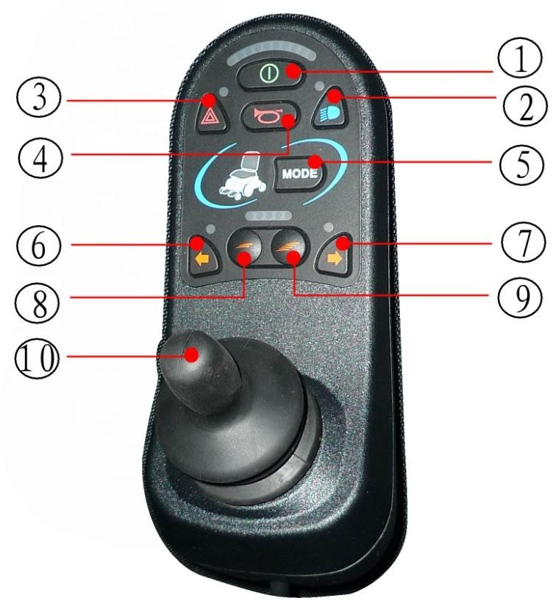

Switch on button

Warning lights button

Driving lights button

Horn button

Mode button

Left turn signal button

Right turn signal button

Deceleration button

Acceleration button

Joystick