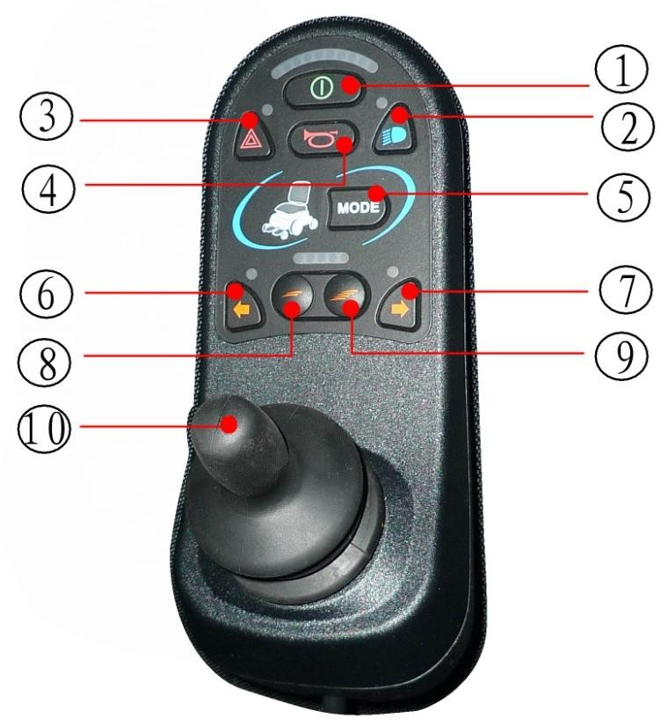

Switch on button

Warning lights button

Driving lights button

Horn button

Mode button

Left turn signal button

Right turn signal button

Deceleration button

Acceleration button

Joystick